Communication and Marketing Resources
Networking Communities
DKG Facebook Groups – Online support groups designed to increase interaction between individuals with shared roles, goals, and passions.
DKG Communications and Marketing – A community dedicated to sharing ideas for communicating and publicizing DKG.

DKG Editors Forum – Community for editors

DKG for Social Media – A DKG community where members can explore venues, best practices, and ethics in the world of social media

DKG Resources
Members must first log in to open the full website
· Get Connected Newsletter Archive -DKG Home>Publications >Newsletters
· Go To Guide -DKG Home >Documents>Go-To Guide
· Guidelines and Policies/Procedures -DKG Home>Documents>GAPP
· DKG Copyright Guidance
· Editors Stylesheet

Additional Resources

· Video to Weebly Website
· Video to a Google Website
· Contact Form in Weebly Website
· Contact Form in Google Website

GetConnected!
The Delta Kappa Gamma Society International January/February 2021
Communications and Marketing Survey –
Where do we go from here?

The Communications and Marketing Committee has reviewed the nearly 400 survey responses and appreciate the information. Throughout the biennium, the committee will revisit identified areas of need and will address them as training opportunities are designed. Here are some of the results.
Webmasters
Webmasters identified Weebly and Google as the platforms most often used. Training needs include creating contact forms, copyright issues, linking to other sites, and inserting photos. They see connecting with other webmasters and learning about other web platforms as beneficial for their position.

What training or support do you need for web development?
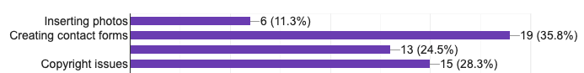*Item three: Link to other sites
Editors
Chapter and State Organization editors identified increased training in minimizing editorial footprint, style guidelines, and copyright issues as needs. Layout, design, and editing text and photos were needs also noted. State Organization editors most often use Word and Publisher for their newsletters and note the need for training on alternate platforms.

What training or support do you need as an editor?

Communications and Marketing Chairs
Communications and Marketing Chairs communicate through email, newsletters, and social media to engage members. Many note the use of the DKG website for resources, tools, and current information. Social media, SO websites, public news articles, and DKG brochures are used to communicate to non-members.
How does your committee promote visibility about DKG to NON-members?