Website: dkgnj.org

@AlphaZetaStateNJ
www.facebook.com/AlphaZetaStateNJ/
@AlphaZetaState
https://twitter.com/AlphaZetaState
Share chapter news and member accomplishments!
Encourage members to read the News Between the News and the AZS Newsletter

Website: dkgnj.org

@AlphaZetaStateNJ
www.facebook.com/AlphaZetaStateNJ/
@AlphaZetaState
https://twitter.com/AlphaZetaState
Share chapter news and member accomplishments!
Encourage members to read the News Between the News and the AZS Newsletter

Website: dkgnj.org

@AlphaZetaStateNJ
www.facebook.com/AlphaZetaStateNJ/
@AlphaZetaState
https://twitter.com/AlphaZetaState
Share chapter news and member accomplishments!
Encourage members to read the News Between the News and the AZS Newsletter

Website: dkgnj.org

@AlphaZetaStateNJ
www.facebook.com/AlphaZetaStateNJ/
@AlphaZetaState
https://twitter.com/AlphaZetaState
Share chapter news and member accomplishments!
Encourage members to read the News Between the News and the AZS Newsletter

Website: dkgnj.org

@AlphaZetaStateNJ
www.facebook.com/AlphaZetaStateNJ/
@AlphaZetaState
https://twitter.com/AlphaZetaState
Share chapter news and member accomplishments!
Encourage members to read the News Between the News and the AZS Newsletter

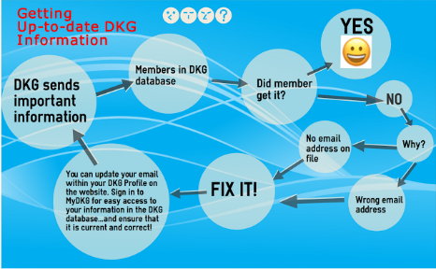
Really connect with DKG. dkg.org
Follow the DKGSI blog:
dkgsi.blogspot.com/
Communication is the key!
Scholarships:
www.dkgef.org/
US Forum:

www.usforumdkg.org/

Really connect with DKG. dkg.org
Follow the DKGSI blog:
dkgsi.blogspot.com/
Communication is the key!
Scholarships:
www.dkgef.org/
US Forum:

www.usforumdkg.org/

Really connect with DKG. dkg.org
Follow the DKGSI blog:
dkgsi.blogspot.com/
Communication is the key!
Scholarships:
www.dkgef.org/
US Forum:

www.usforumdkg.org/

Really connect with DKG. dkg.org
Follow the DKGSI blog:
dkgsi.blogspot.com/
Communication is the key!
Scholarships:
www.dkgef.org/
US Forum:

www.usforumdkg.org/

Really connect with DKG. dkg.org
Follow the DKGSI blog:
dkgsi.blogspot.com/
Communication is the key!
Scholarships:
www.dkgef.org/
US Forum:

www.usforumdkg.org/

